REFER TO ANNE AND YOCTO THROUGHOUT, AS CHARACTERS WITH QUALITIES, INTERROGABLE, DEFINABLE. WHAT IS GOOD ABOUT THEM? WE CAN’T ANSWER THIS HERE, OBVIOUSLY. BUT HERE ARE SOME WAYS TO TALK ABOUT QUALITY. OTHER EXAMPLES.
- Both artists and audiences are very concerned with the ‘quality’ of character, both as a marker of ‘quality’ of its particular fictive form and as interrogable in their own right. (Recent examples of this).
- Mercer (2006) - “When we engage critically with a literary work, we are not merely describing it, making it accessible to other readers; at the same time we judge it, explicitly or by implication”.
- As in the Observer - “whether it’s Oliver Twist or Harry Potter, Hester Prynne or Katniss Everdeen, literary characters offer us a chance to vicariously experience life in all its drama, humor, mystery, and adventure.”
- We “come to know” characters.
- (Murray) - "as Forster pointed out... we are more interested in characters who are capable of surprising us than in those who are flat and predictable."
- When we like a text, we “want… to make it part of our world” (Altieri)
- ““Great” books are, in part, considered to be great because of their cognitive value... some literature, despite being fictional, can teach readers important things about the real world” (Hepola). This is the theory of literary cognitivism. This is not necessarily her view, she is talking abstractly about literary cognitivists - does not admit to being one.
- “Absorptive power” of fictional narratives.
- “Sometimes a novel can affect a person’s whole identity” (Oatley)
- “We would no sooner read a novel that did not move us, than an empirical articles that did not offer a validly drawn conclusion.” (Oatley)
- We talk about the “impact” of narrative (Narrative Impact book)
- We are “interested in the fate” of characters (Nomura and Akai, 2012).
- There are many different qualities, often pointing to different aspects of the character and its portrayal, but what about the character as a whole? What about non-specifics? (Academic context for this, or save until next section?)

The Book Group

- Shadowing a book group, hear about how readers (as opposed to academics) think about characters who they have just read.

- They praised character’s ‘believability’, and the author for ‘painting a picture’ (two people said this separately).
- “when we discuss a novel, we must discuss its characters”

- Kafka is over-descriptive, in their view; no space for the self.
- They cursed some minor characters as ‘clunky devices’, others as ‘well-drawn’. They could ‘relate’ to certain characters, were “keen on” others. Some were “plausible”, others were “vivid”, even if they were “minor”. “Some where just devices that were brought in to serve a purpose and then leave”
- These people, like millions of others across the world, were engaged in critical judgements of ‘quality’, very particularly not just of narratives, but of the characters which inhabited them.
- The appearance of Colonel Sanders in Kafka - “unbelievable” - he “trivialised it”

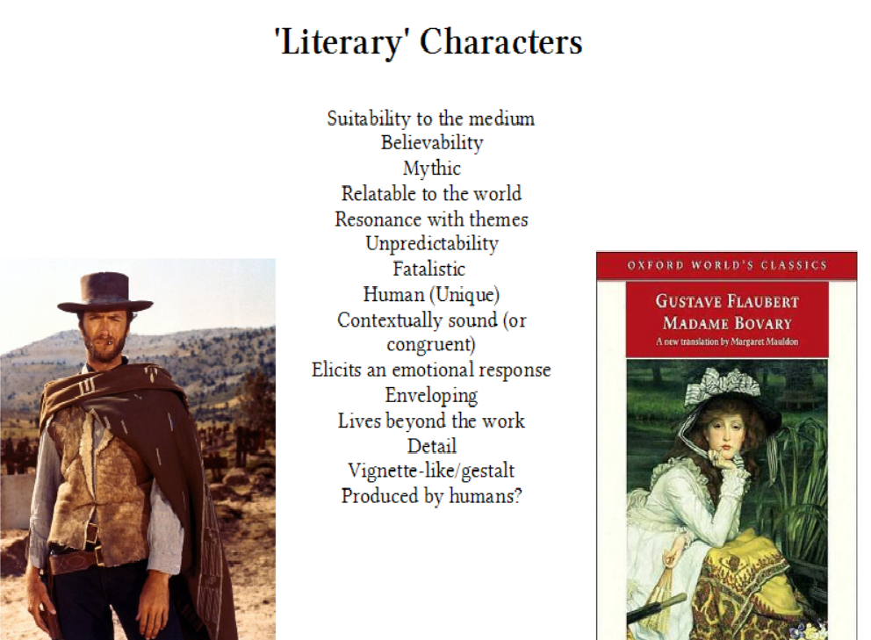
(My own brainstorm of qualities of characters. I am not using the term ‘literary’ anymore, as it is loaded and media-specific. These qualities (or are they techniques?) augment those below).

Words Often Used To Denote This ‘Quality’

- “evocative” (Turkle, 2007);
- well-written;
- “sympathetic” (Oatley, 1995);
- vivid;
- “realistic” (Gard, 2000);
- human;
- “rich” (Nicolopoulou & Richner, 2007);
- well-shot;
- “engaging” (Heidbrink, 2014);
- skillfully-drawn;
- “fully imagined” (Murray, 1999);
- unforgettable;
- “enduring” (Murran, 2016);
- immortal;
- “Life-like” rather than alive;
- Thomas & Johnson 1981 - believable characters provide an “illusion of life”
- “robust” (Wawro, 2016);
- evocative.

These seem to evince my previous theory of assaying characters as constructed individuals, rather than mere devices.

A criticism of this approach is that there are many different aspects to a quality character, which differs depending on their medium and context. However, I feel that we can look generally at character, as despite differences in media, authorship and context they are broadly attempting to do different things. This links into audience reception theory and the like. They are all trying to produce an effect and affect; while the nature of these may differ, the objective remains broadly the same. I will, of course, be looking at some of these objectives more than others; which ‘resonant’ approaches I personallly find satisfying and suitable. I may need some textual backup for this idea.

Resonance

- We can sum all of these up as ‘resonance’?
- I define 'resonance' as those qualities of any character, in any artform, which stimulate, engage and permit interaction with the imaginative capacity of the audience.
- That which interests them, holds their attention (attention will become more important later).
- I am addressing that part of characterisation that speaks to the audience.
- A brief foray into the drum metaphor?
- As with the book group, they painted the picture, not the author!
- Based on our imagination, our senses, our remembered and current experiences.
- Partiality allows resonance

